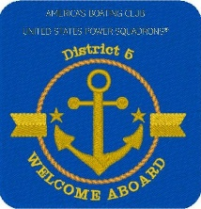
America’s Boating Club – Mid-Atlantic
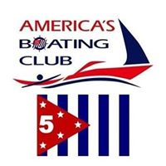
2026 Summer Rendezvous
RESERVATION FORM
28-30 August 2026
Lankford Bay Marina, Rock Hall, Maryland

MEMBER: Rank ______ Name ___________________________________________ Grade ____
ADDRESS _______________________________________________________________________
SQUADRON ________________________________ POSITION __________ FIRST TIMER? ______
E-Mail ___________________________________________________ PHONE _________________
SPOUSE/OTHER ATTENDEES:
Rank ___ Name ______________________________________ Grade _____ FIRST TIMER? _____
Rank ___ Name ______________________________________ Grade _____ FIRST TIMER? _____

REGISTRATION FEE # _____ @ $10.00 = $ ___________

SATURDAY ENTRÉE CHOICES:
Chef Zach’s Famous Pulled Pork w/ House Made BBQ Sauce
served with toppings/rolls to make sandwiches # _____ @ $28.00 = $ ___________
BBQ Boneless Thighs & Breasts served with toppings/rolls
to make sandwiches # _____ @ $28.00 = $ ___________
Portobello. Tomato, Mozzarella Sliders with
Creamy Italian Dressing # _____ @ $28.00 = $ ___________

Selections served with Cole Slaw, Pasta Salad (tri-color pasta w/tomato, olive, feta and Italian dressing), Market Fresh Salad with House Made Ranch or Balsamic. Dessert: Assorted cookies and brownies. Lemonade, Tea & Water

Total Enclosed: $ ____________

Dietary Restrictions: ________________________________________________________________

Recommended Dress for Saturday Dinner: Casual

MAKE SLIP RESERVATIONS DIRECTLY WITH MARINA – Call Candy at 410-778-1414. Please mention that you are with the D/5 Summer Rendezvous. Reserve early to be given a slip close to the group.

The slip rate is $2.75 per foot, single electric is $9.00 and double electric is $17.00

Meal Reservations must be received by 13 August 2026!
Make Checks Payable to: ASPS
Send to:
Georgiana Maszczenski
103 Little Neck Road
Stevensville, MD 21666
E-mail: gmaszczenski@hotmail.com

