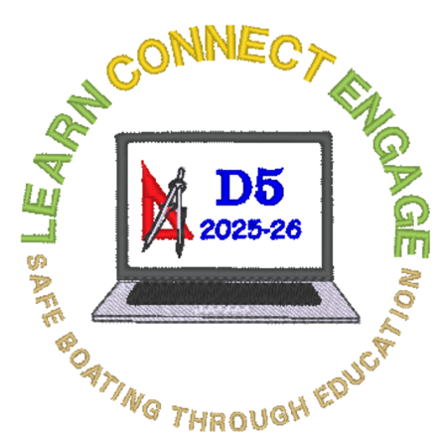
2026 District Five Spring Conference Agenda
Thursday 26 March, Ice Cream Social for Early Arrivals D5 Commander’s Hospitality Suite
Friday 27 March Dress Code: Informal/Squadron Shirts
Date | Start | End | Session | Room | Open
27 MAR | 0830 | 1130 | CPR - Registration Instructions on Reverse | Orlando | Yes
27 MAR | 0900 | 1600 | Registration and 50/50 Ticket Sales | Conference Lobby | Yes
27 MAR | 0900 | 1600 | Raffle Table | Conference Lobby | Yes
27 MAR | 0900 | 1600 | Secretary’s Table | Conference Lobby | Yes
27 MAR | 0900 | 1030 | Coffee & Morning Mingle | Conference Lobby | Yes
27 MAR | 0930 | 1030 | M&R Committee Meeting | Harrison South | Yes
27 MAR | 1030 | 1200 | Officer Training - Education/Assistant Officers | Berlin | Yes
27 MAR | 1030 | 1200 | Officer Training -Administrative/Assistant Officers | Harrison North | Yes
27 MAR | 1030 | 1200 | Officer Training - Secretaries | Harrison South | Yes
27 MAR | 1200 | 1330 | Lunch on Your Own
27 MAR | 1200 | 1330 | Visit 50/50 & Raffle | Conference Lobby | Yes
27 MAR | 1330 | 1500 | Officer Training - Treasurers | Harrison North | Yes
27 MAR | 1330 | 1500 | Officer Training - Commanders/Executive Officers | Berlin | Yes
27 MAR | 1230 | 1630 | First Aid - Registration Instructions on Reverse | Harrison South | Yes
27 MAR | 1500 | 1700 | Instructor Recertification | Orlando | Yes
27 MAR | 1500 | 1600 | iMIS Discussion | Berlin | Yes
27 MAR | 1530 | 1600 | New Aides Roles & Responsibilities | Harrison North | No
27 MAR | 1600 | 1700 | Bridge Meeting | Cdr’s Suite | No
27 MAR | 1700 | 1900 | Dinner on Your Own
27 MAR | 1900 | 2100 | Hospitality Suites | 4th Floor Rooms | Yes
Saturday 28 March Dress Code: Blue Blazers With Grey Slacks
Date | Start | End | Session | Room | Open
28 MAR | 0830 | 1400 | Registration and 50/50 Ticket Sales | Conference Lobby | Yes
28 MAR | 0830 | 1400 | Raffle Table | Conference Lobby | Yes
28 MAR | 0830 | 1400 | Secretary’s Table | Conference Lobby | Yes
28 MAR | 0830 | 0900 | Coffee & Morning Mingle | Conference Lobby | Yes
28 MAR | 0900 | 0930 | Spring Council Meeting | Orlando | Yes
28 MAR | 0930 | 1015 | Past Chief Commander’s Message & Town Hall | Orlando | Yes
28 MAR | 1015 | 1145 | America’s Boating Channel | Orlando | Yes
28 MAR | 1100 | 1230 | BOC & OTW Programs | Orlando | Yes
28 MAR | 1030 | 1130 | Newsletter Editor’s Meeting | Harrison North | Yes
28 MAR | 1030 | 1130 | Law Committee: Insurance Issues Q&A | Harrison South | Yes
28 MAR | 1130 | 1230 | Build Your Own Squadron Seminar & Discussion | Harrison North | Yes
Continued on Reverse
28 MAR | 1230 | 1400 | Member Luncheon & Guest Speaker | Conference Lobby | Yes
28 MAR | 1230 | 1400 | Visitb50/50 & Raffle – Last Call for Raffle | Conference Lobby | Yes
28 MAR | 1400 | 1630 | Spring Conference Meeting | Orlando | Yes
28 MAR | 1500 | 1630 | Raffle Prize Pickup | Conference Lobby | Yes
Dress Code for Banquet: Class A Uniform Black Tie or Appropriate Attire
28 MAR | 1700 | 1730 | Incoming Bridge Photos | D5 Hospitality | No
28 MAR | 1730 | 1830 | District Commander’s Reception | D5 Hospitality | Yes
28 MAR | 1930 | 2200 | Banquet &B Change of Watch | Orlando/Berlin | Yes
28 MAR | 2130 | 2200 | Last Call for 50/50 Followed by Drawing | Orlando/Berlin | Yes
29 March Dress Code for New Bridge Reception Informal/New Bridge Members Attire
29 MAR | 0800 | 0830 | New Bridge Assembles for Reception | Harrison South | No
29 MAR | 0830 | 1000 | New Commander’s Reception | Conference Lobby | Yes
Safe Travels Home

Registration Instructions for CPR & First Aid Training Cost $30.00
URL | https://tinyurl.com/2026SpringABCCPR
Or Scan QR Code With Your Smart Phone Camera | 

