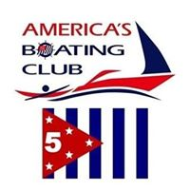
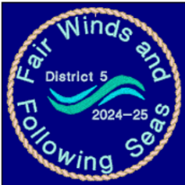
United States Power Squadrons/District 5
America’s Boating Club – Mid-Atlantic
2024 Summer Council
RESERVATION FORM
25-28 July 2024
Solomons Island, Maryland

MEMBER: Rank ______ Name ___________________________________________ Grade ____
ADDRESS _______________________________________________________________________
SQUADRON ________________________________ POSITION __________ FIRST TIMER? ______
E-Mail ___________________________________________________ PHONE _________________
SPOUSE/OTHER ATTENDEES:
Rank ___ Name ______________________________________ Grade _____ FIRST TIMER? _____
Rank ___ Name ______________________________________ Grade _____ FIRST TIMER? _____

REGISTRATION FEE # _____ @ $10.00 = $ ___________

SATURDAY BUFFET:
Mission Barbecue: Adults # _____ @ $35.00 = $ ___________
Sliced Brisket, Pulled Chicken Child 7-17 # ______@ $ 5.00 = $ ___________
Baked Beans, Baked Cheesy Potatoes Child 6 + Under N/C
Sliders/Cornbread
Desserts. Drinks

Total Enclosed: $ ____________

Dietary Restrictions: ________________________________________________________________

Dress Codes: Friday - Squadron Shirts; Saturday Flag Raising: Uniform D; Saturday Dinner: Squadron/District Shirts

MAKE SLIP RESERVATIONS DIRECTLY WITH MARINA – Safe Harbor Zahnisers Marina (410) 326-2166; Spring Cove Marina (410) 326-2161
Holiday Inn Express (240) 237-1444; mention USPS D/5 Summer Rendezvous

Meal Reservations must be received by 13 July 2024!
Make Checks Payable to: Patuxent River Power Squadron
Send to:
Lenore Blevins
46135 River Hill Road
Lexington Park, MD 20653

