SUMMER CRUISE 2023
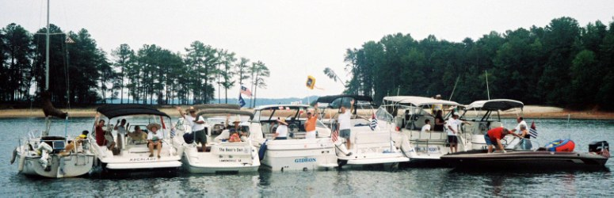
Join District 5 for a fantastic cruise to Langford Bay Marina, Rock Hall, MD. District 5 has put together
a short distance cruise and any and all can join at any time. We are planning to stop at the below marinas and of course will have activities at each stop which will include cocktail parties.
21-22 July Baltimore Anchorage Marina (39 16.88’N, 076 34.96W
A great spot to start the cruise for the Northern boats…great restaurants and shopping nearby. Sadly, the Orioles are not in town those days.

23-24 July Kent Narrows, Safe Harbor Marina (38 9735’N, 076 2455W)
A beautiful marina in Kent Narrows which has fantastic facilities, very nice pool, and a couple of restaurants on premise.
For boats coming from the South, a good place to meet the cruise.
23 NM from Anchorage Marina Please make your reservations via DOCKWA and under “special” put in D5 Power Squadron.

July 25-26 St Michaels Marina (410) 226-6330///(410) 745-2460 (38 47.10’N, 076 13.21’W)
A quaint stop and during the week not as expensive as the weekends.
There are many little shops, a nautical museum and great restaurants. A stop you don’t want to miss.
24 NM from Bay Bridge Marina

July 27-30 Lankford Bay Marina (410) 778-1414 (39 07.29’N, 076 10.69W)
A neat marina on the Chester River, east side of Rock Hall, where
District 5 will hold their festivities so graciously hosted by Annapolis Sail and Power Squadron. The Summer Council will be held there and, also there will be a host of games for everyone. It will be the event of the Summer!
23 NM from St Michaels

Please contact RALPH BERNARD, rb3513@comcast.net, 609.226.6773, for further information and to join in the fun cruising with District 5.

