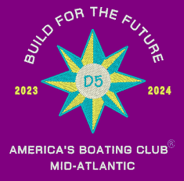
2023 America’s Boating Club Mid-Atlantic
District 5 Fall Conference
3-5 November 2023
Maritime Institute, Linthicum Heights, MD

MEMBER

Rank Name Grade __

Address City State Zip ______________

Phone E-mail Squadron

OTHER ATTENDEES
Rank Name Grade
Rank Name Grade
Rank Name Grade

Friday & Saturday Lunch & Breaks
# _____
# _____

Friday Lunch & Breaks

Saturday Lunch & Breaks (All meals include: Fresh Field Green Includes: Lunch Buffet, Morning & Afternoon Breaks, AV Equipment

SATURDAY NIGHT DINNER
Chef’s Buffet
# _____ @ $40.00 $ _______
Dinner cost is only for those not staying at the Maritime Institute

TOTAL ENCLOSED $_______

All Reservations must be submitted by 19 October 2023. You must submit the reservation form to be counted for attendance. Please submit the form by email to aprylber@msn.com.
This is for the seminars only

Make checks payable to: United States Power Squadron-District 5

PLEASE SEND RESERVATION FOR DINNER WITH CHECK TO:

Apryl Bernard, 1127 Riverside Drive, Mays Landing, NJ 08330
(609) 432-7449 aprylber@msn.com

Hotel Reservations: By 19 October 2023
Maritime Institute, 692 Maritime Boulevard, Linthicum Heights, MD 21090
Reservations: https://gettaroom.b4checkin.com/mccbwi/#main; Group Code:4966 at top of screen (866) 900-3517, ask for America’s Boating Club Mid-Atlantic 2023
Hotel Rates: $165 Single Occupancy, $210.00 Double Occupancy
Room rates include breakfast and dinner.

